# Heart Disease Prediction

# Wireframe Documentation

Written by :- AMIT KUMAR

As per the problem statement, I have divided analysis into three sections:

1. Heart disease data analysis according to B.P , cholesterol and sugar .

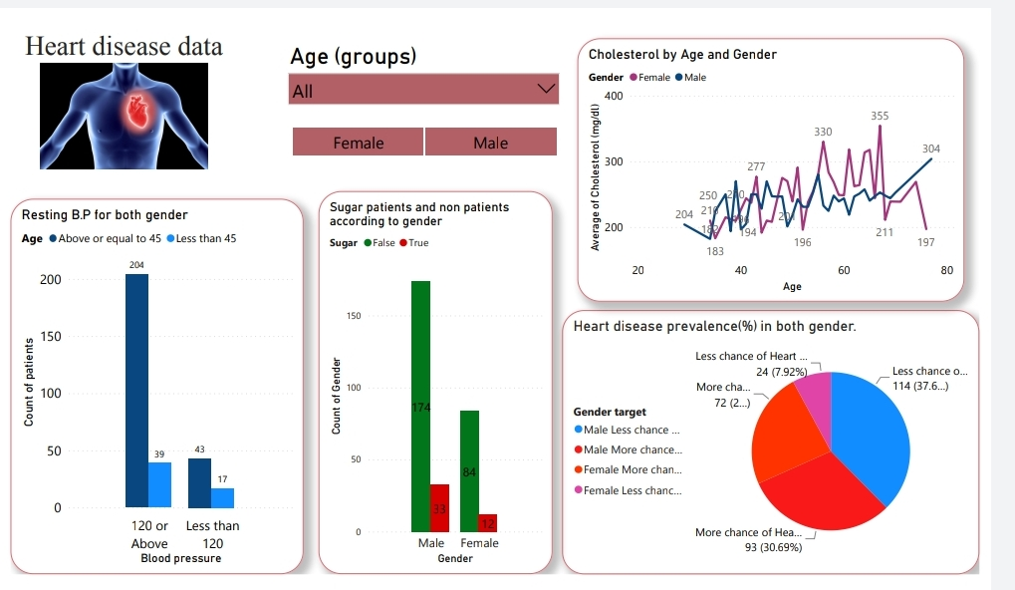

In this section I designed the dashboard and tried to interpret the followings :

.

# The person's cholesterol measurement in (mg/dl) by age and gender.

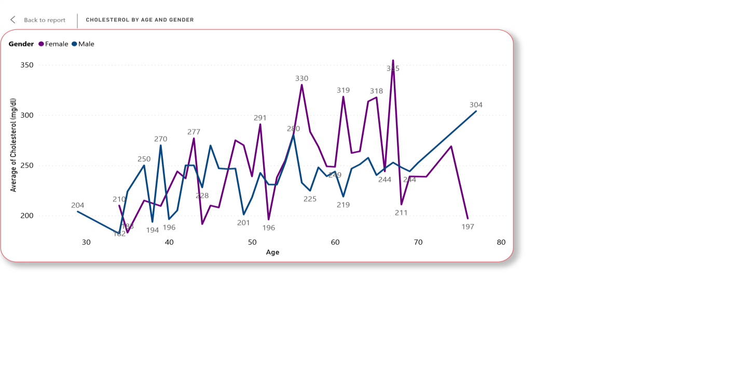

# The person's resting blood pressure (mm Hg ) according to age group for both gender. 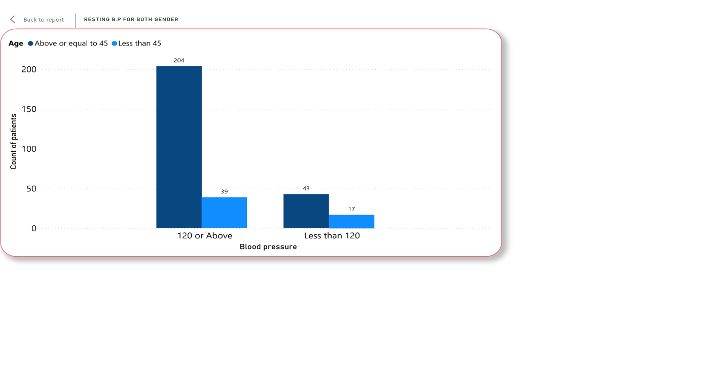

# Heart disease prevalence (%) in both gender categorized as patient with more chance of heart attack . and less chance of heart attack.

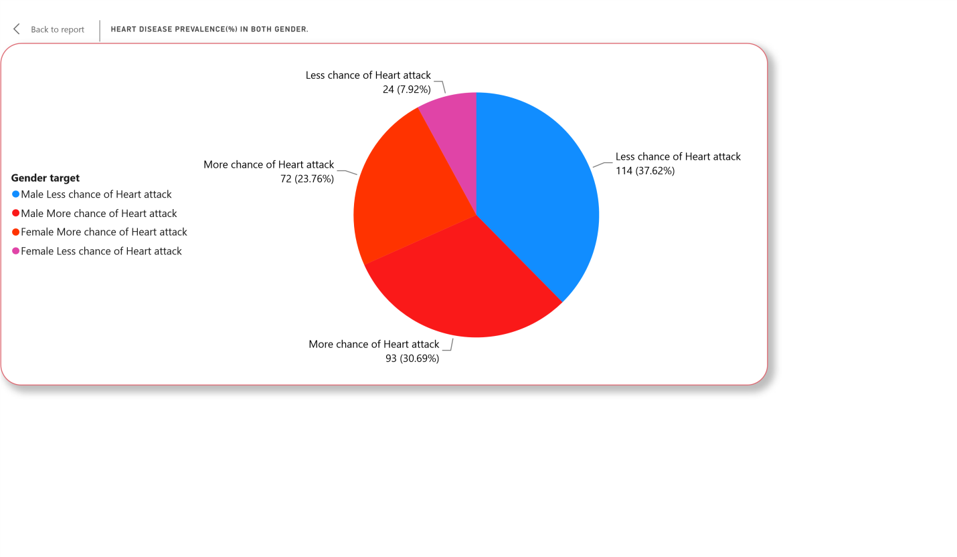

# Patients suffering from Blood sugar .

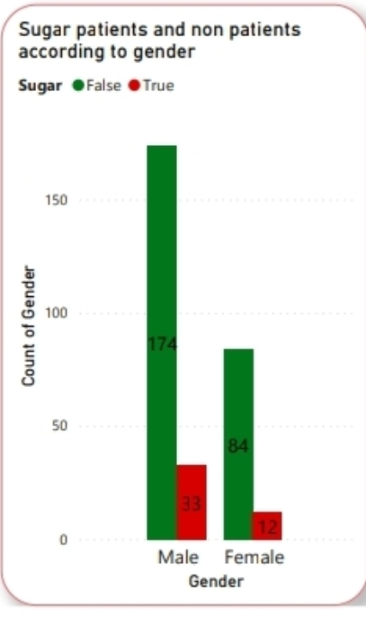

2. Patients data according to Ecg , Chest pain and some valuable insights. 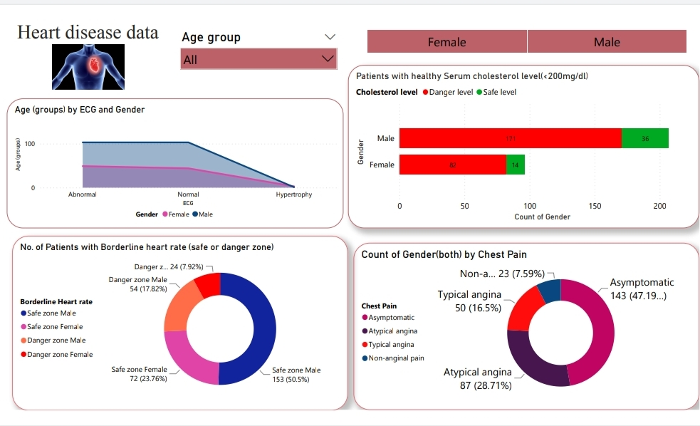

#  Resting electrocardiographic data according to age group and gender.   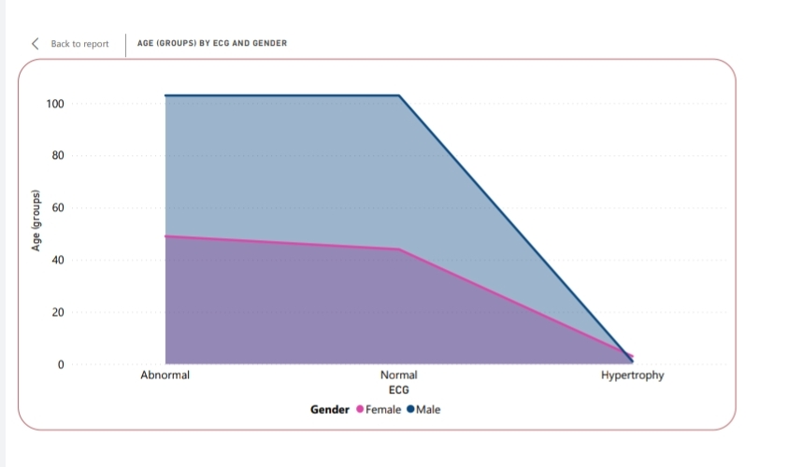

# No. of patients with healthy serum cholesterol level (<200 mg/dl)

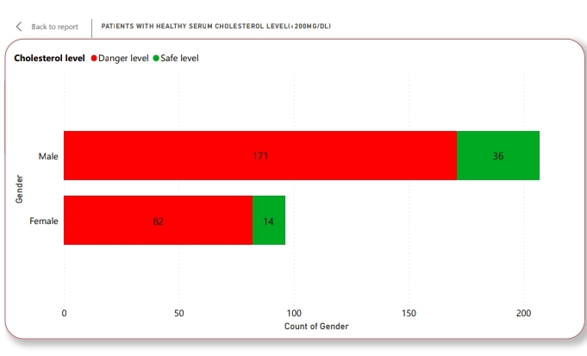

# No. of patients with borderline heart rate ( safe or danger zone)

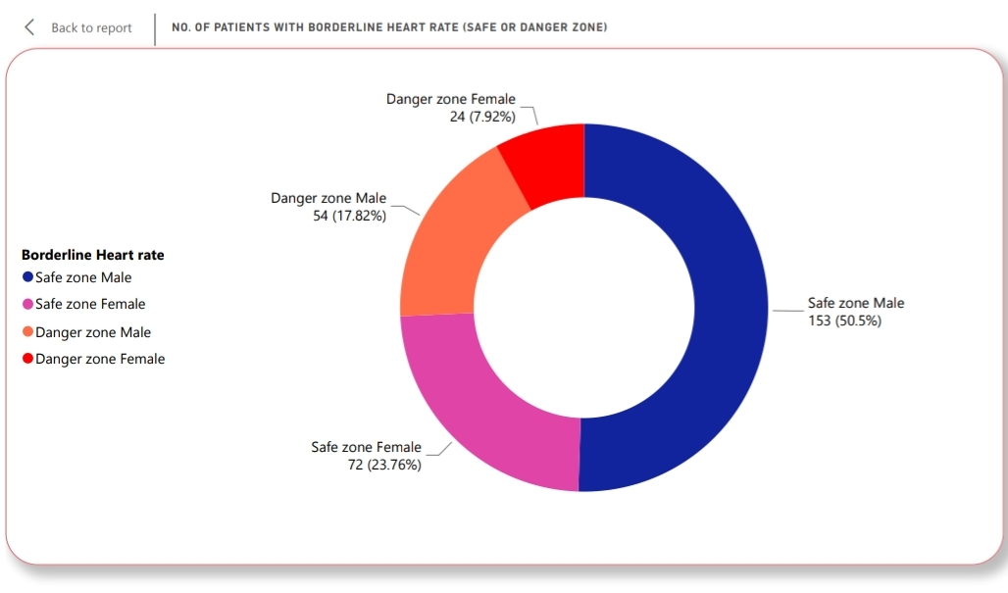

# No. of patients suffering from different types of chest pains .

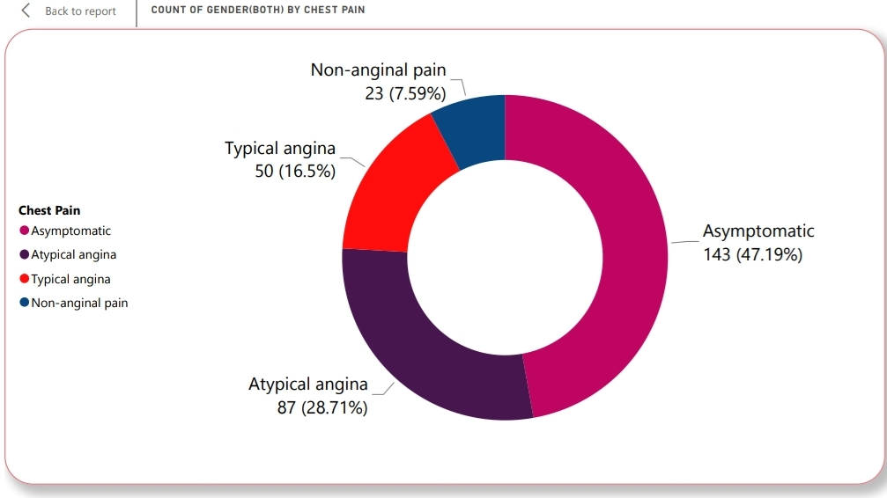

3. Patients data according to blood disorder and some insights.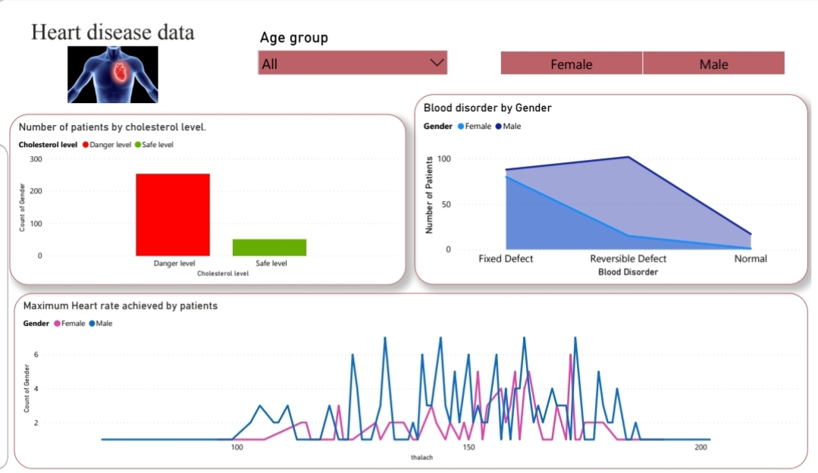

# Number of patients suffering from  blood disorder called thalassemia .

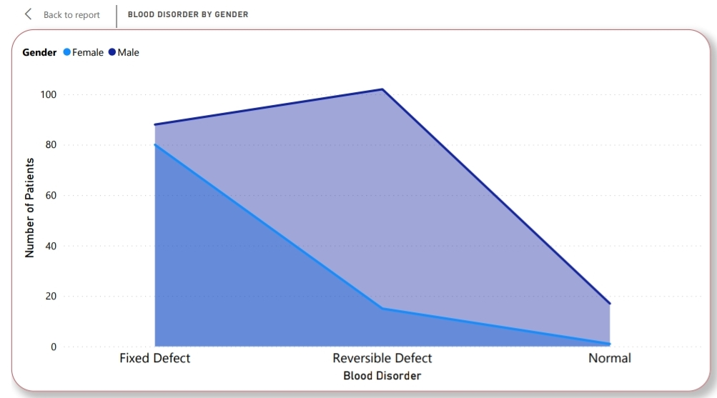

# Total number of patients with high cholesterol level and are in danger zone.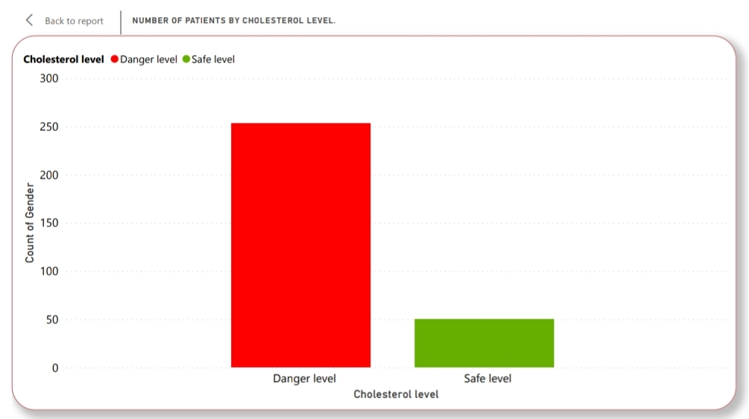

# Maximum heart rate achieved by patients.